**Sprint 2 Plan**

**Heading**:

Product Name: BeatBox

Sprint Completion Date: July 16th, 2023

Revision Number: 1

Revision Date: July 9th, 2023

**Goal:** Allow the user to upload audio clips (wav or mp3 file, 2 seconds max, 1 MB max), control instrument channel volume, download the drum pattern (wav file), and control instrument channel panning.

**Task Listing and Initial Assignments:**

**1. Upload Button**: As a musician, I want to upload my own sounds so I can use instruments that match my ideas better than the default instruments. (Priority: High) (Story Points: 8)

**Tasks:**

1. Add an Upload Button to the purple instrument channel, clicking it will prompt the user to select an audio file on their system to upload to the instrument channel. (2 hours)
2. Replace the instrument channel’s default sound with the user’s audio file. (2 hours)
3. Limit the audio files accepted: audio files must be wav or mp3 format, 2 seconds in length max, 1 MB max in file size. (2 hours)
4. File uploads outside the range of accepted files will open a small pop-up window with the text “File must be ‘wav’ or ‘mp3’ format, up to 2 seconds long, and up to 1 MB in size!” - Add an “OK” button to the upload error pop-up window. Pressing “Enter” or “Esc” or clicking the “OK” button closes the upload error pop-up window. (2 hours)

**2. Volume Knob**: As a musician, I want to change the volume of certain sounds so all the different sounds are balanced with each other. (Priority: High) (Story Points: 5)

**Tasks:**

1. Add a Volume Knob to the purple instrument channel. Clicking the Volume Knob and dragging changes the volume level from 0 to 100. (2 hours)
2. Mousing over the Volume Knob displays the current volume level. (1 hour)
3. Double-clicking the Volume Knob resets the volume level back to 100. (2 hours)

**3. Download Button**: As a musician, I want to download my drum loop so I can use it in a real song. (Priority: High) (Story Points: 8)

**Tasks:**

1. Clicking the Download Button will prompt the user to enter a filename and a save location on their system (2 hours)
2. Render the drum pattern (6 hours)
3. Allow the user to download the render as a lossless wav file. (4 hours)

**4. Panning Knob**: As a musician, I want to change the panning of certain sounds so I can use spatial positioning to make the soundstage more immersive. (Priority: High) (Story Points: 5)

**Tasks:**

1. Add a Panning Knob to the purple instrument channel. Clicking the Panning Knob and dragging changes the panning amount from -100 to 100. (2 hours)
2. Mousing over the Panning Knob displays the current panning amount. (1 hour)
3. Double-clicking the Panning Knob resets the panning amount back to 0. (2 hours)

**Team Roles:**

**Product Owner**: Dakota Rubin

**Scrum Master**: Clarissa Sepulveda, Jose Patino

**Team**: Andrew Yniguez, Clarissa Sepulveda, Dakota Rubin, Jose Patino, Victor Maher, Victoria Moore

**Initial Burnup Chart:**

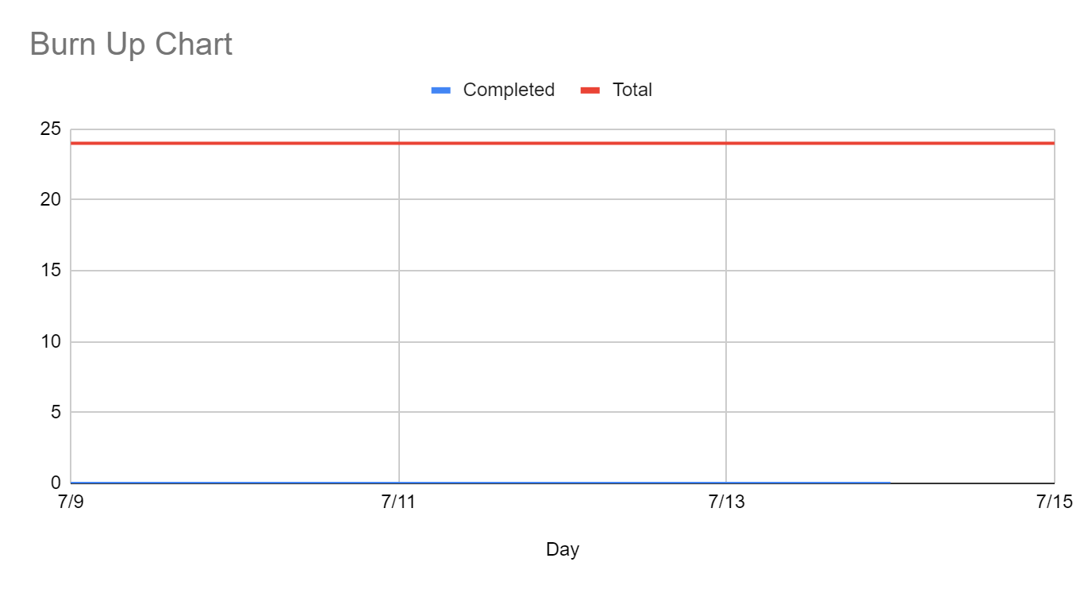

**Initial Scrum Board:**

Hosted on Trello: https://trello.com/b/alEVMUhs/agile-task-board

**Scrum Times:**

1. Tuesday, July 11th @ 3:00 PM (Online)
2. Wednesday, July 12th @ 5:00 PM (Online)
3. Friday, July 14th @ 5:30 PM (Online)